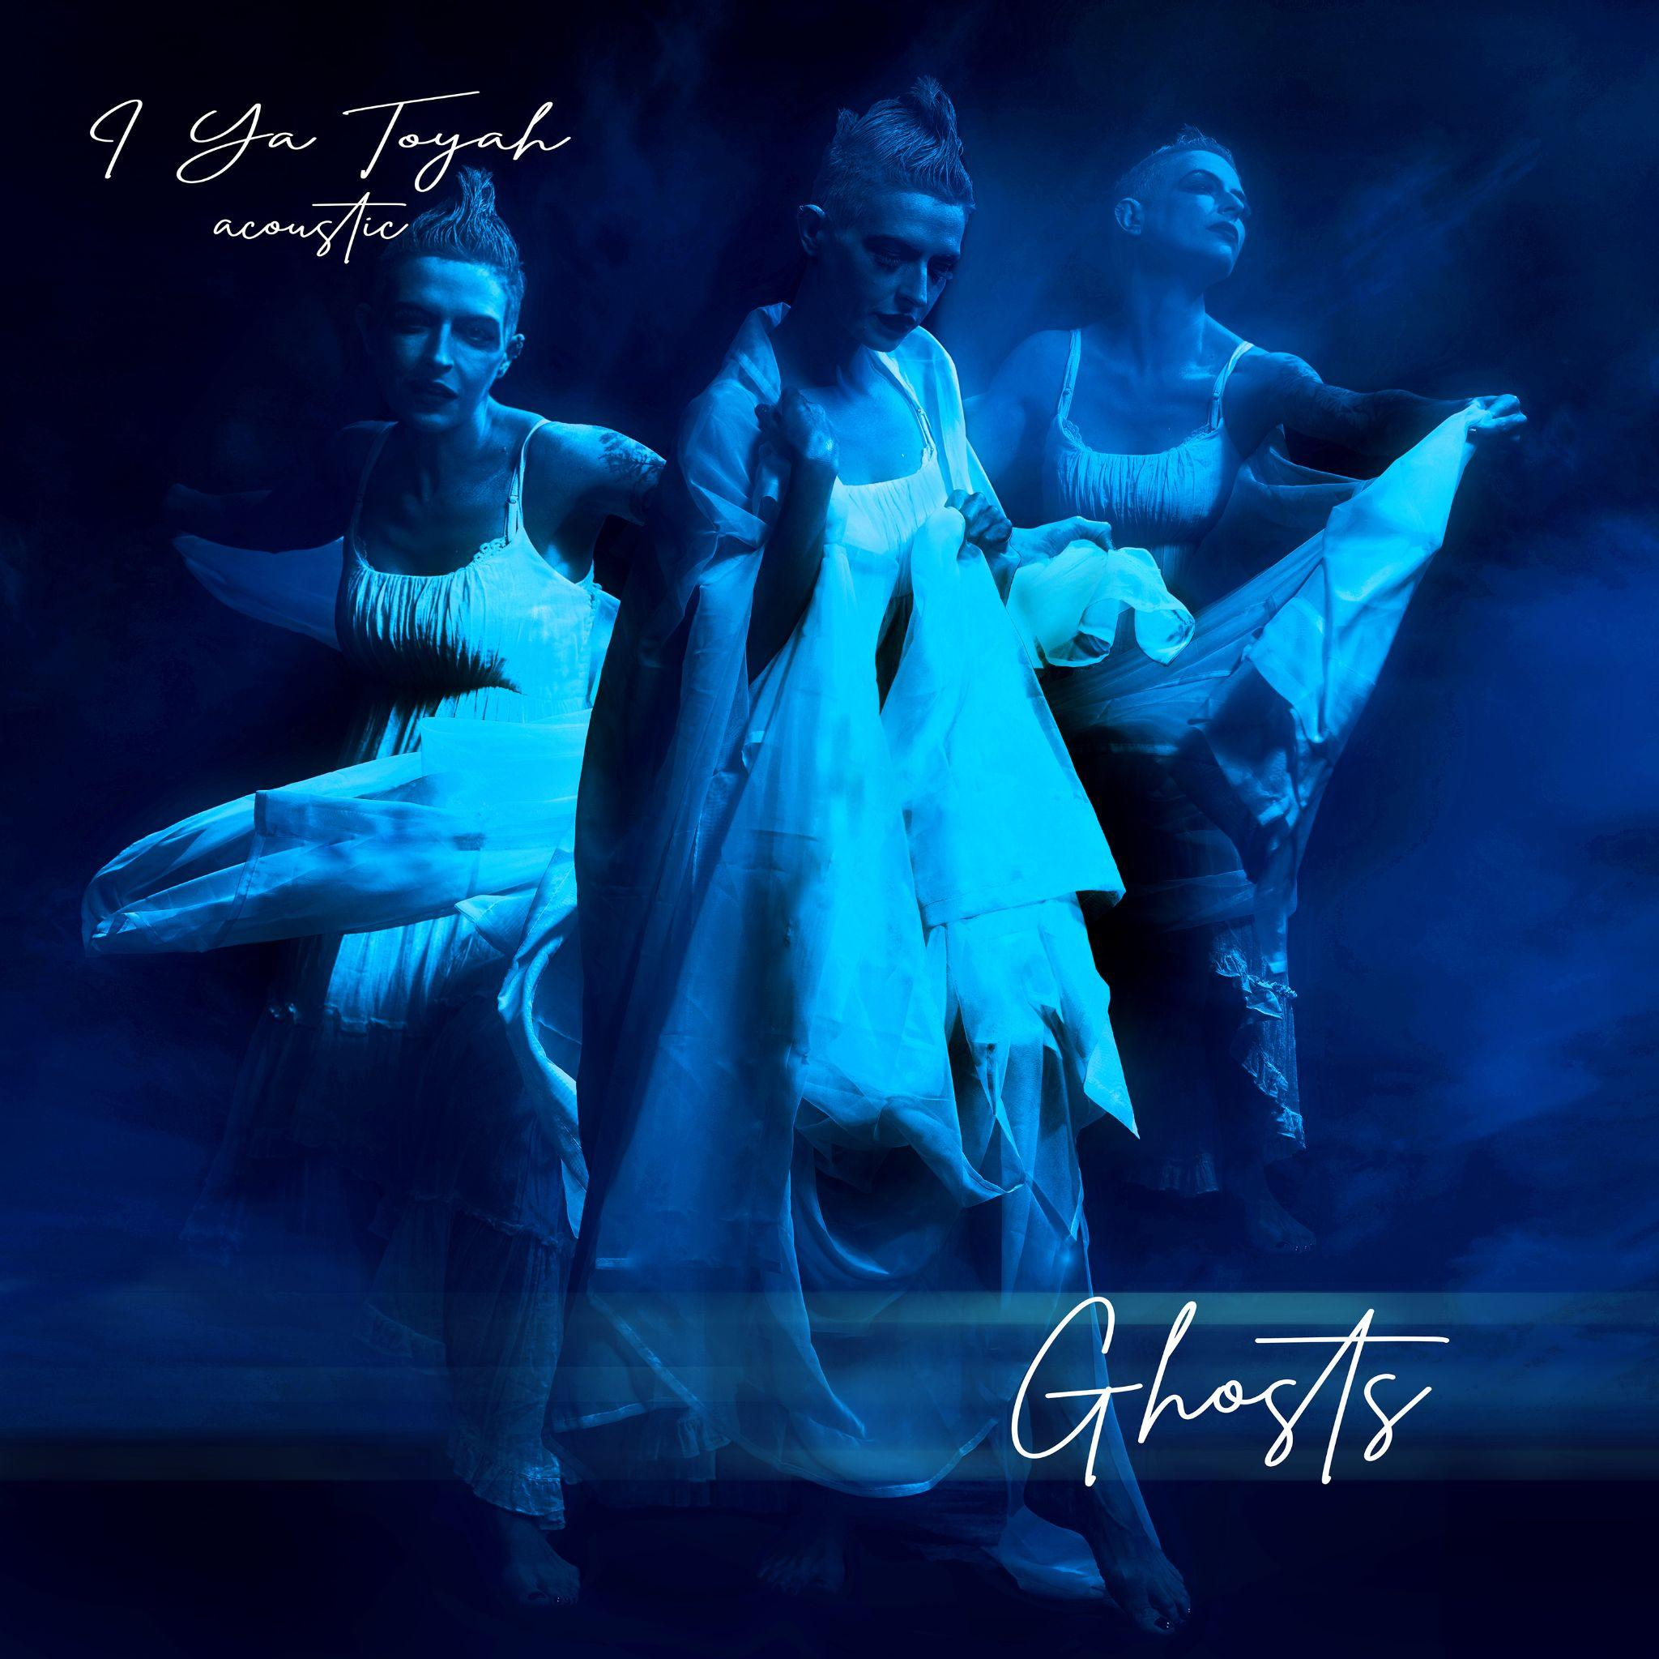
FOR IMMEDIATE RELEASE
October 28, 2022

I YA TOYAH ANNOUNCES GHOSTS ACOUSTIC EP

Chicago-based “one woman musical army” known as I Ya Toyah announces the release of Ghosts, a brand new acoustic EP that is scheduled for release Oct 28. The EP will feature haunting acoustic renditions of three of her previously-released songs: Pray from last year’s Out of Order EP, and Code Blue and Time Machine; both from her critically-acclaimed 2018 debut album, Code Blue.

Stylistically, Ghosts is a drastic departure for I Ya Toyah. Gone are the waves of industrial noise and caustic harshness that defined her previous recordings; replaced by the unexpected intimacy of a single piano and her voice, which manages to effortlessly maneuver between delicacy and goosebump-inducing power. And while this change may surprise fans of her previous work, I Ya Toyah’s Ania Tarnowska feels like it’s the perfect time to make a statement such as this.

“Countless music industry professionals have tried to put boundaries on me and the music THEY think I should be making,” Tarnowska explains. “Many have even advised against releasing something as musically different as Ghosts. But I have more than one color, and more than one dimension. And for me, being able to express the entire array of human emotions is one of the most satisfying parts of making music.”

“I believe I should be able to create something harsh, like Out of Order, and then turn around and release something as delicate and beautiful as Ghosts. Because they are BOTH me,” she continued. “This EP is a celebration of the independent spirit, and the freedom to create that has been the backbone of I Ya Toyah from the very beginning. And that is why I am so confident that my true fans will be willing to join me on this journey.”

Pre-orders for Ghosts begin on Friday, October 7 on I Ya Toyah’s Bandcamp page (https://iyatoyah.bandcamp.com/album/ghosts-2), and the EP will become officially available on Friday, October 28 exclusively through Bandcamp.
The first single ‘Pray’ will be released on all digital platforms on Oct. 28 followed by 2 singles this winter and the full EP Ghosts (Jan. 27, 2023)
In addition to the digital release, two physical items will be available: a limited-edition CD, with exclusive bonus audio content and a holographic sticker, and a small batch of Ghosts posters, hand signed when requested.

15% of all physical album sales go to aid Suicide Prevention and Mental Health Cause, promoting the 988 Crisis Line.

More information: https://www.iyatoyah.com

